**Lab #06**

**Objective: To become familiar with RMI.**

**HelloInterface.java**

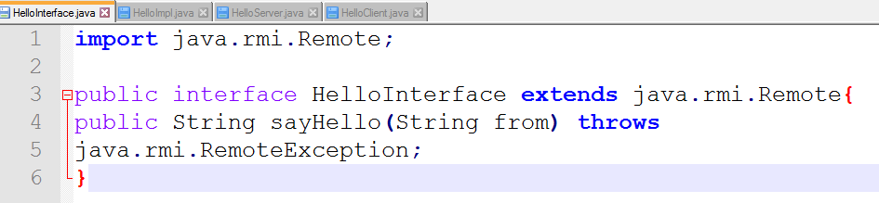

**HelloImpl.java**

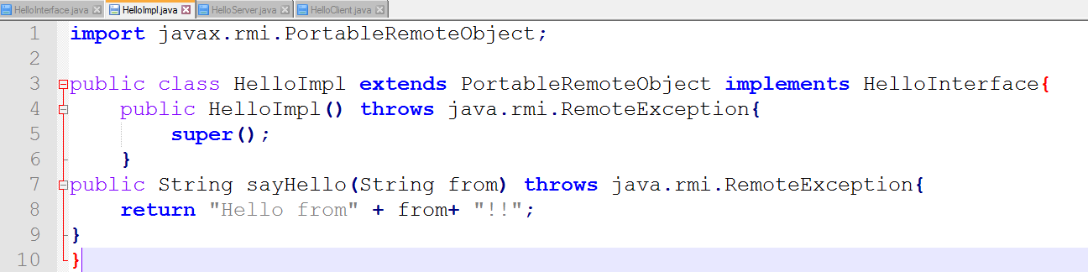

**HelloServer.java**

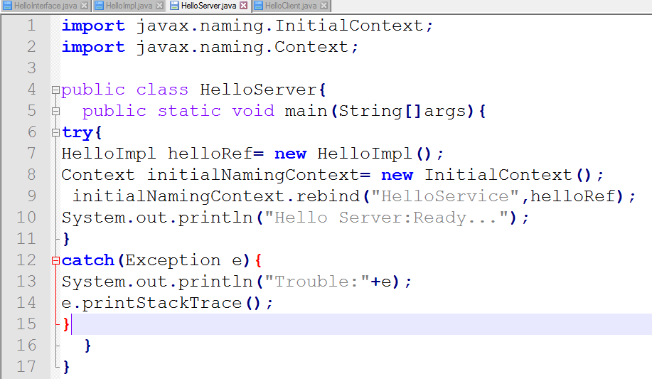

**HelloClient.java**

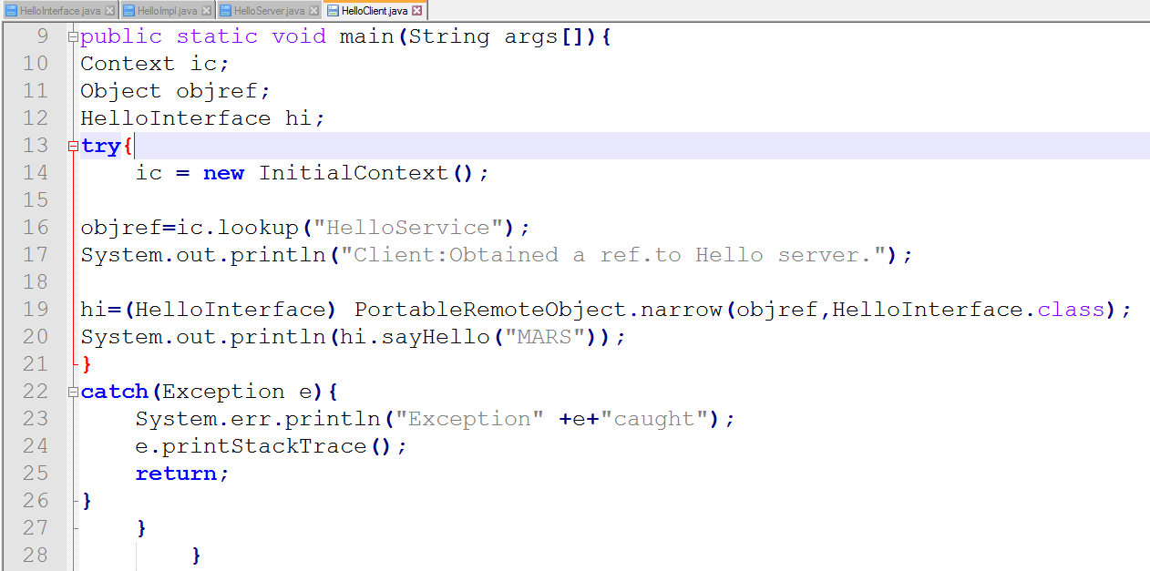

**Output:**

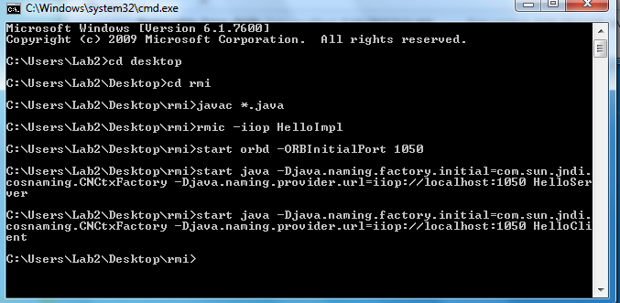

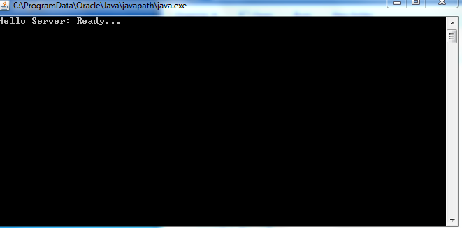

**Lab Task**

Create RMI IIOP application in which take a sentence at runtime on the client application and let the server return its reverse.  
E.g. input could be: subject is distributed computing   
output should be: computing distributed is subject.

**Server side**

**HelloInterface.java**

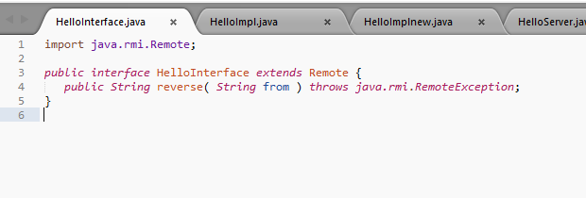

**HelloImpl.java**

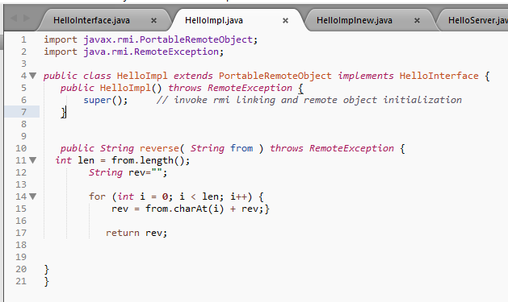

**HelloServer.java**

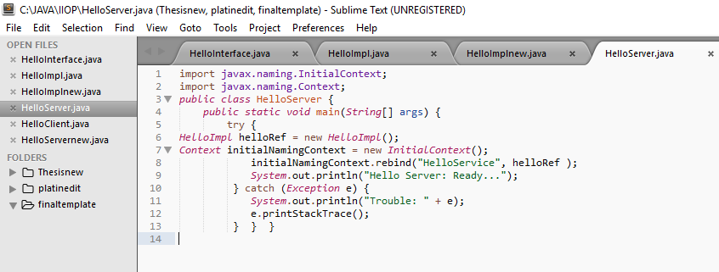

**output**

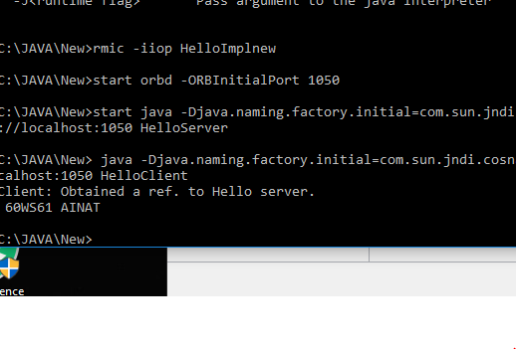

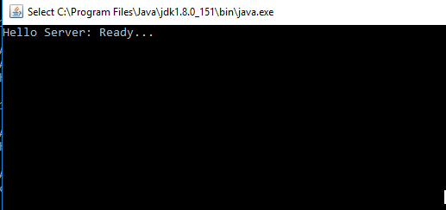

Client Side

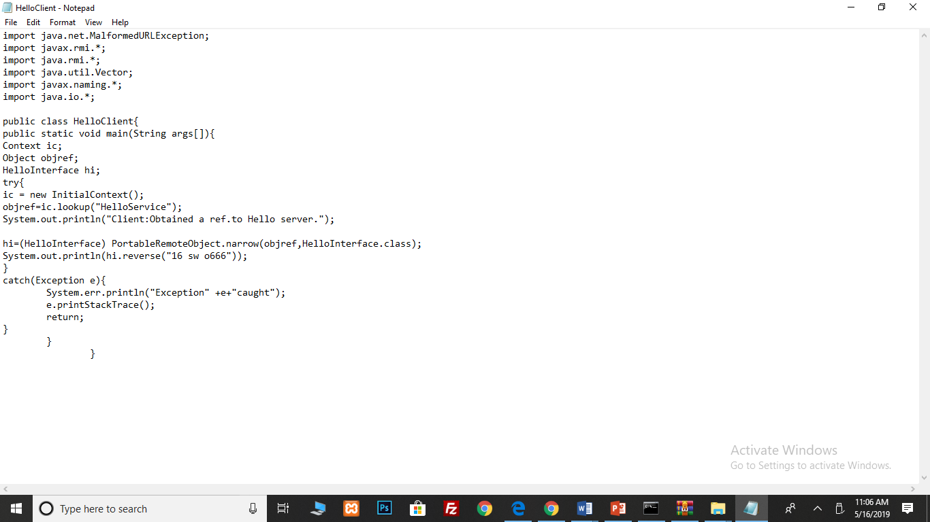

Output:

